**OLDE NORTH WEDDING CHAPEL**

**200 North 11th Street**

**1987-2005 Olde North Wedding Chapel**

**1973-1986 No Entry**

**1956-1972 Pentecostal Tabernacle**

**1905-1955 First Evangelical United Brethren (EUB)**

**1879-1904 United Presbyterian**

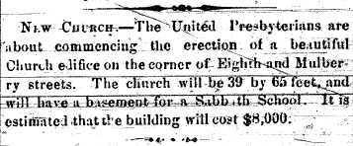

**Humming Bird. Saturday Morning,**

**September 8, 1866, page 3, column 3.**

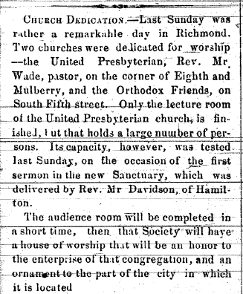

**Hummingbird. Saturday Morning,**

**September 21, 1867, page 3, column 1.**

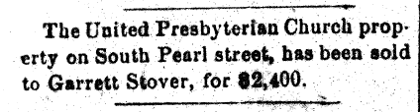

**Richmond Palladium. July 25, 1867,**

**Page 3, column 1.**

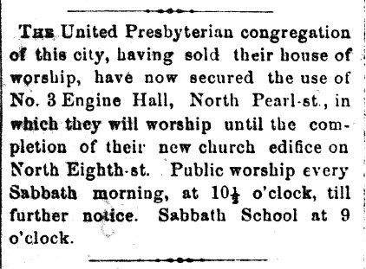

**Richmond Palladium. July 25, 1867,**

**Page 3, column 2.**

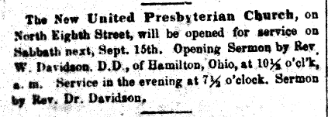

**Richmond Palladium. September 12, 1867,**

**Page 3, column 1.**

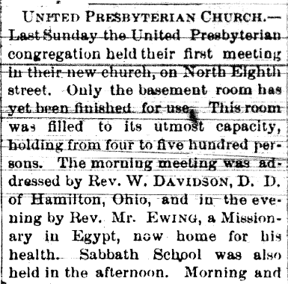

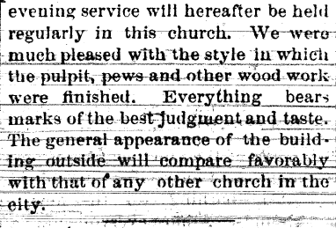

**Richmond Weekly Telegram. Saturday,**

**September 21, 18667, page 5, column 5.**

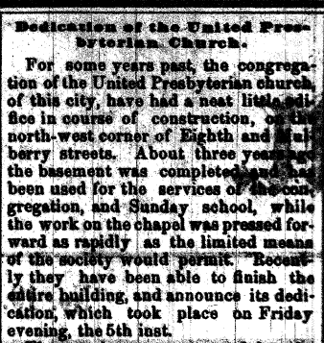

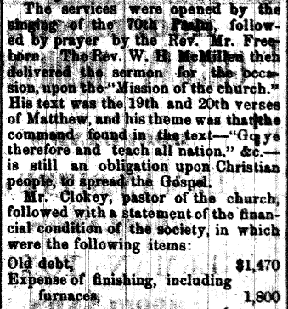

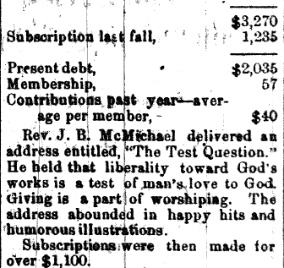

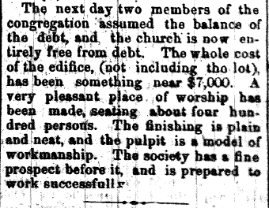

**Richmond Weekly Telegram. Friday,**

**May 12, 1871, page 2, column 2.**

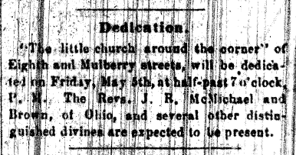

**Richmond Palladium. April 29, 1871,**

**Page 3, column 3.**

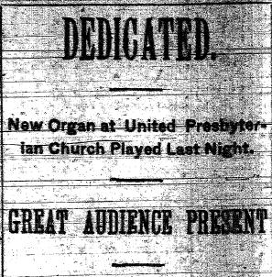

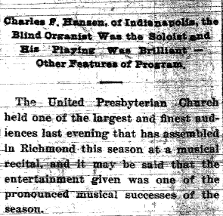

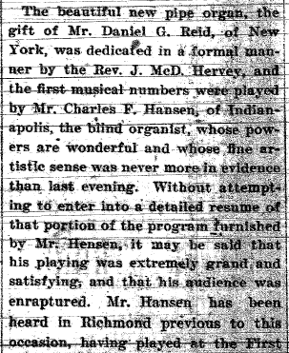

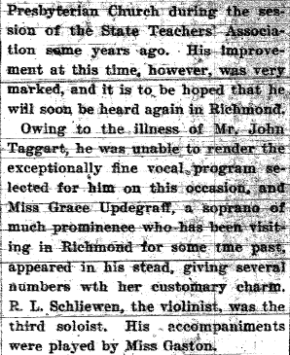

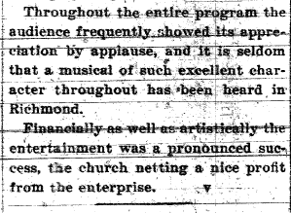

**Evening Item. Wednesday, March 13, 1901,**

**page 5, column 3.**

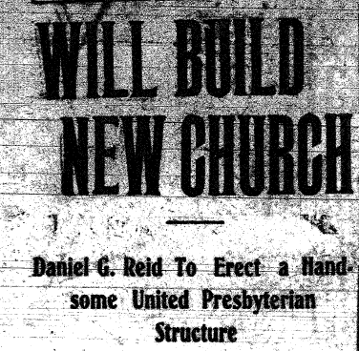

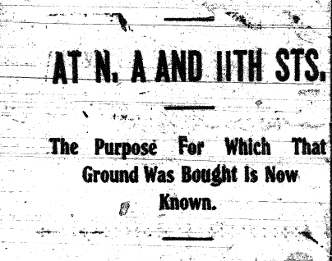

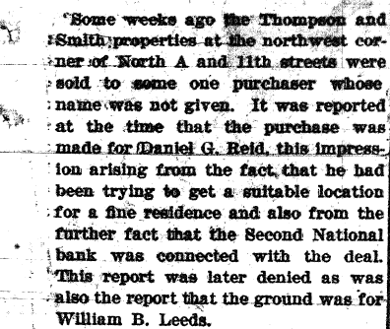

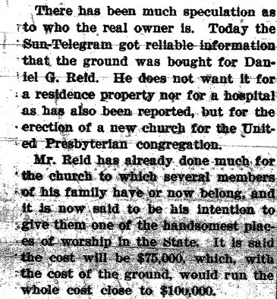

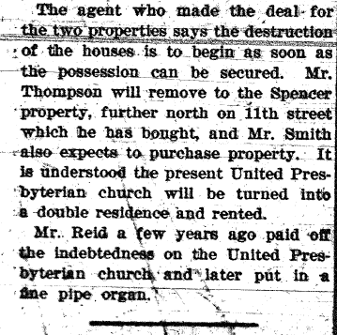

**Daily Sun Telegram. Thursday Evening,**

**November 20, 1902, page 1, column 1.**



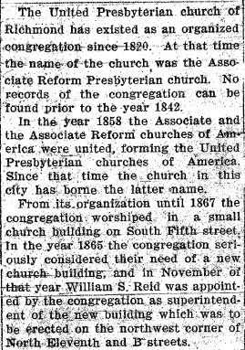

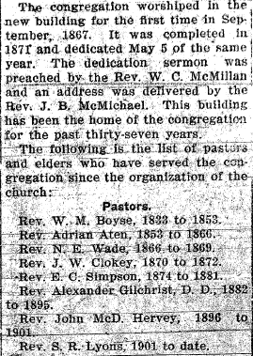

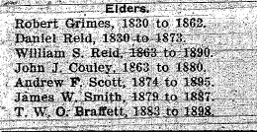

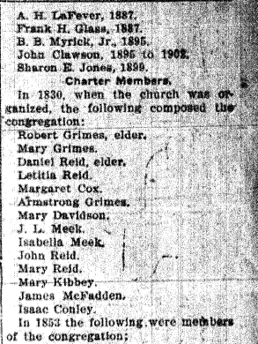

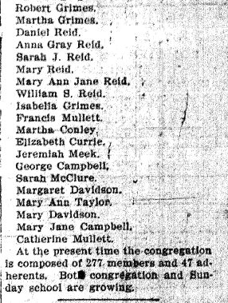

**Evening Item. Monday,**

**May 14, 1906, page 5, column 7.**

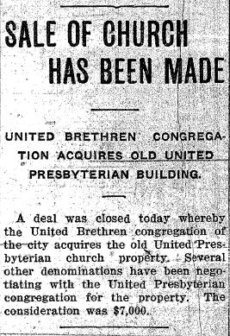

**Evening Item. Saturday,**

**June 16, 1906, page 3, column 4.**

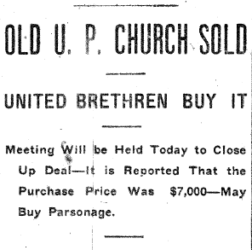

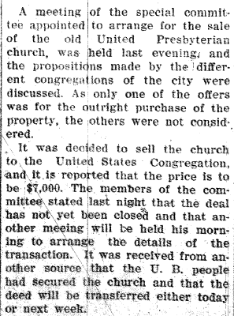

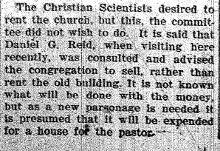

**Richmond Palladium. Saturday Morning,**

**June 16, 1906, page 1, column 2.**

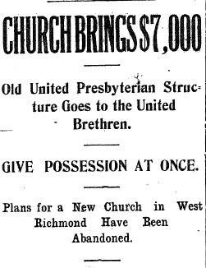

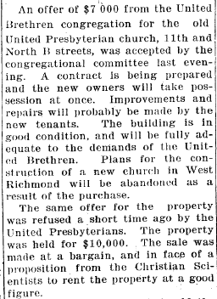

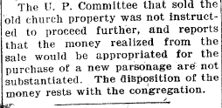

**Sun Telegram. Saturday Evening,**

**June 16, 1906, page 1, column 2.**

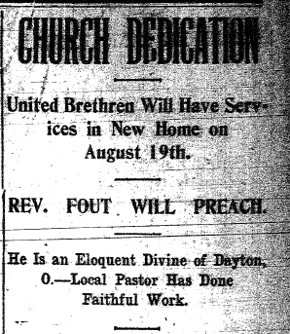

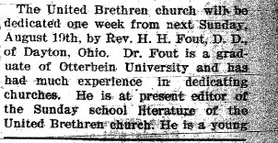

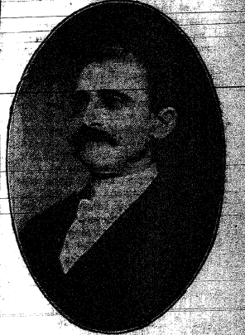

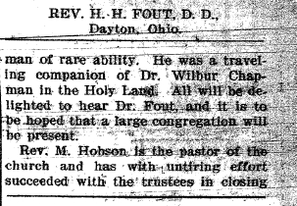

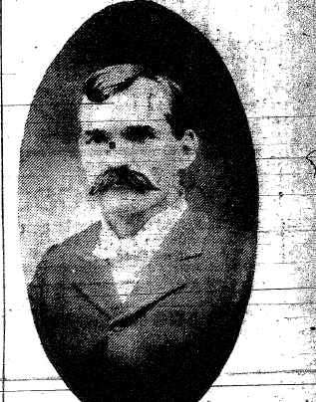

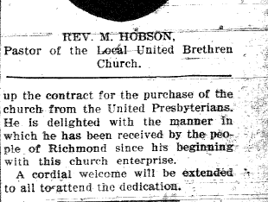

**Richmond Sun Telegram. Thursday Evening,**

**August 9, 1906, page 1, column 7.**

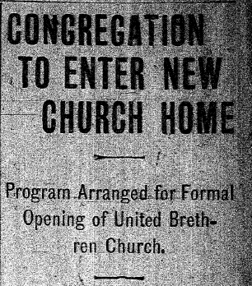

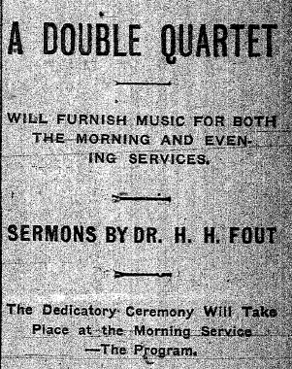

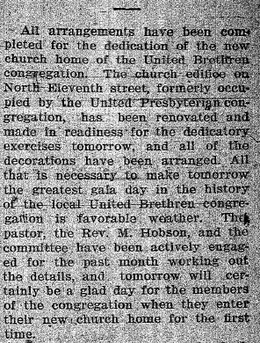

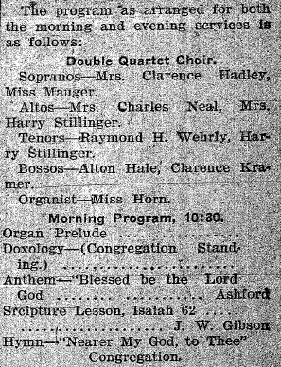

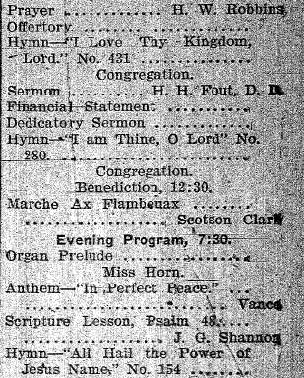

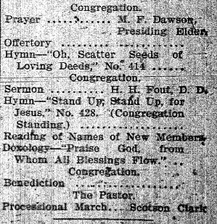

**Evening Item. Saturday, August 18, 1906,**

**page 1, column 8.**

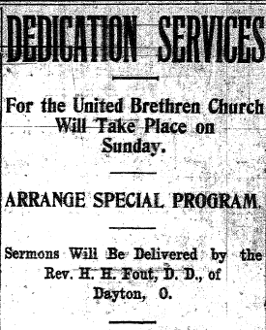

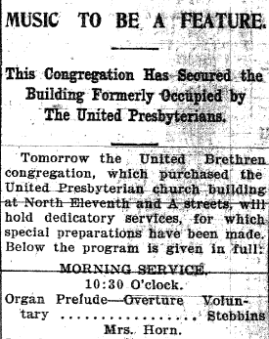

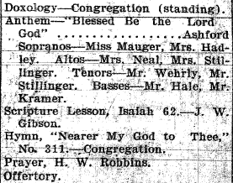

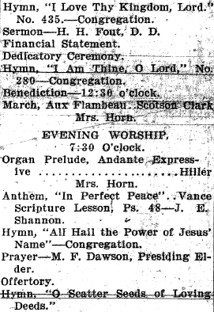

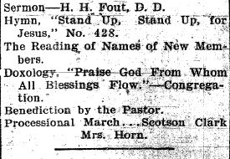

**Richmond Sun-Telegram. Saturday Evening,**

**August 18, 1906, page 1, column 5.**

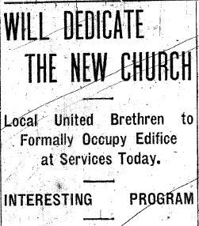

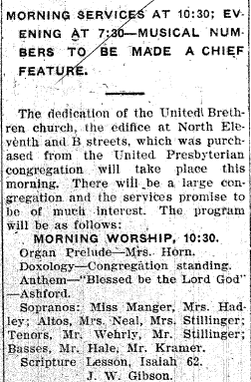

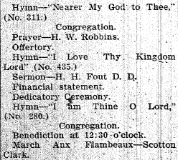

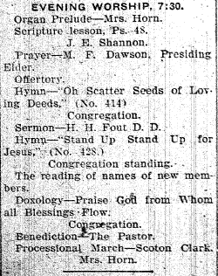

**Richmond Palladium. Sunday Morning,**

**August 19, 1906, page 6, column 2.**

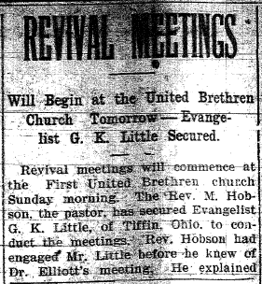

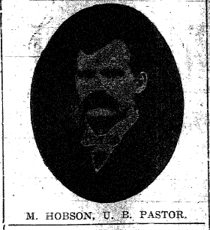

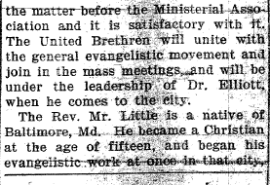

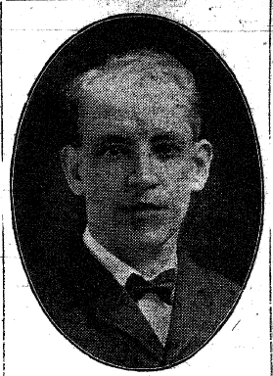

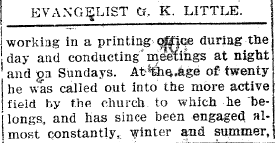

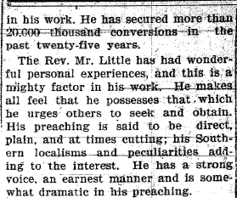

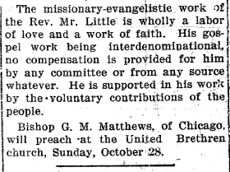

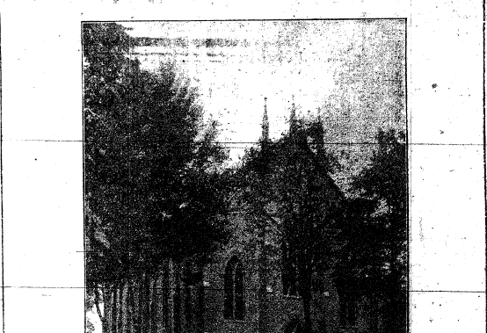

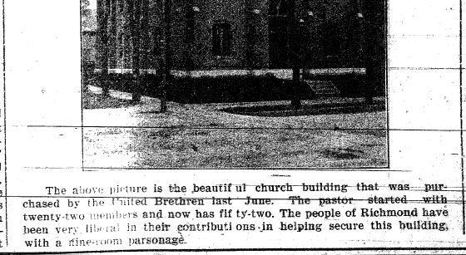

**Richmond Sun-Telegram. Saturday,**

**October 13, 1906, page 5, column 4.**

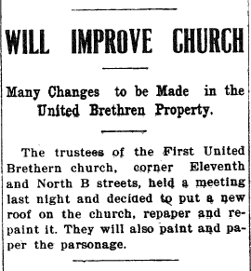

**Richmond Morning News. Wednesday Morning,**

**May 13, 1908, page 1, column 3.**

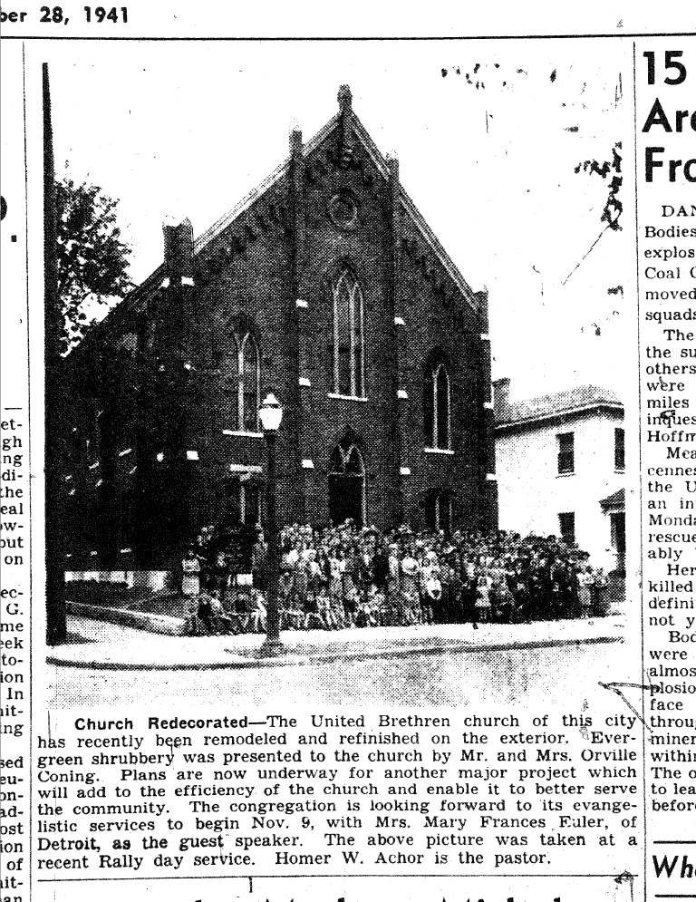

**Palladium-Item & Sun-Telegram. City Edition.**

**Tuesday, October 28, 1941, page 8, column 6.**

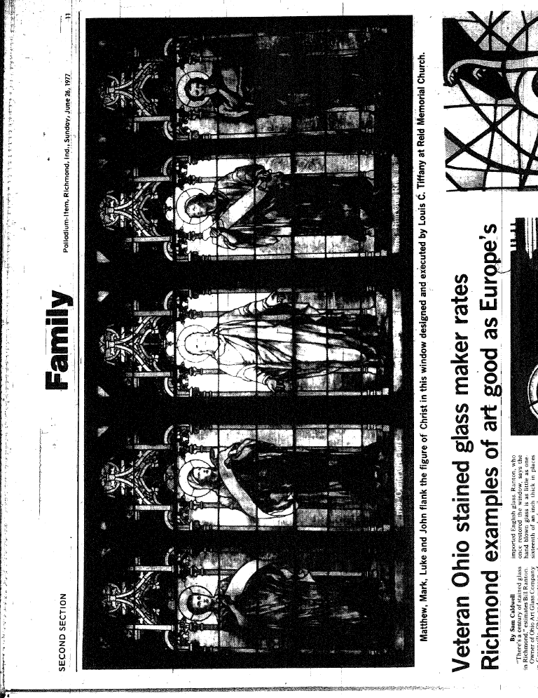

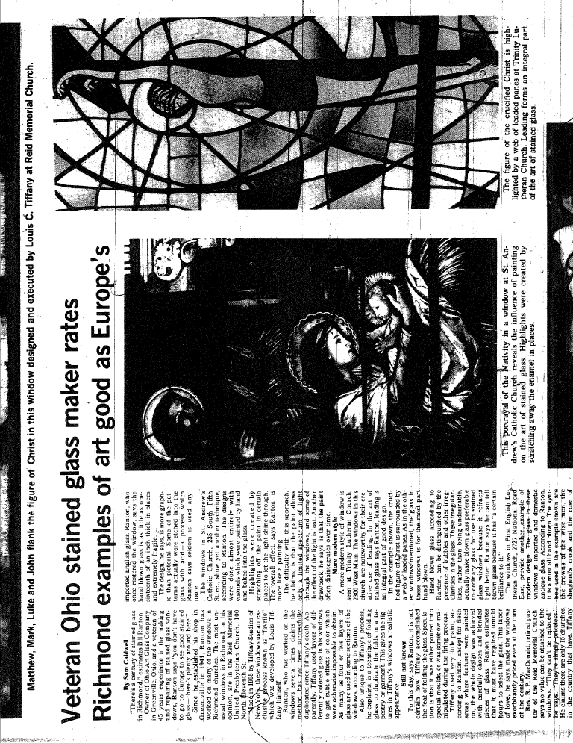

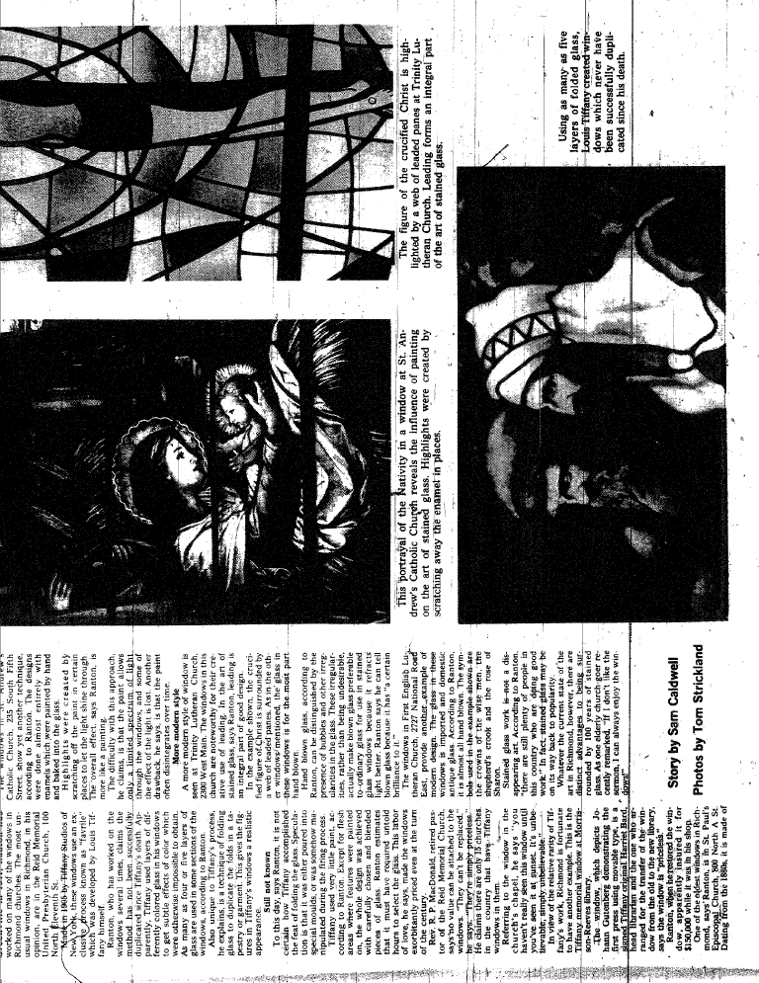

**Palladium-Item. Sunday, June 26, 1977,**

**Second Section, page 11, column 1.**